ACID Compliance

💾 What is ACID Compliance in Databases?
# Source: AI Source: Provided by: [Data Path: Persons Table -> ID Column: 1, Name_En Column: Motasem Essam] -> From: [ChatGPT] on [6/10/2026]
ACID is a set of properties that ensure reliable processing of database transactions. It guarantees data integrity, especially when dealing with multiple operations or users.

🔍 ACID Stands For:
# Source: AI Source: Provided by: [Data Path: Persons Table -> ID Column: 1, Name_En Column: Motasem Essam] -> From: [ChatGPT] on [6/10/2026]
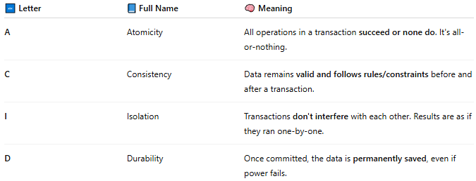
🔤 Letter | 📘 Full Name | 🧠 Meaning
A | Atomicity | All operations in a transaction succeed or none do. It's all-or-nothing.
C | Consistency | Data remains valid and follows rules/constraints before and after a transaction.
I | Isolation | Transactions don't interfere with each other. Results are as if they ran one-by-one.
D | Durability | Once committed, the data is permanently saved, even if power fails.

📦 Real-World Example:
# Source: AI Source: Provided by: [Data Path: Persons Table -> ID Column: 1, Name_En Column: Motasem Essam] -> From: [ChatGPT] on [6/10/2026]
Imagine you transfer money from Account A to Account B:
- Deduct $100 from A
- Add $100 to B
✅ Atomicity: If step 2 fails, step 1 must rollback
✅ Consistency: Total money in the system remains correct
✅ Isolation: Other users can't see a half-completed transfer
✅ Durability: Once completed, power loss won't undo the transfer

✅ Databases That Follow ACID:
# Source: AI Source: Provided by: [Data Path: Persons Table -> ID Column: 1, Name_En Column: Motasem Essam] -> From: [ChatGPT] on [6/10/2026]
- MySQL
- PostgreSQL
- Oracle
- SQL Server
- SQLite
Many NoSQL databases are not fully ACID-compliant by default (for speed/scalability), but some (like MongoDB with transactions) support ACID in limited contexts.

